Mobility & Mechanical Design

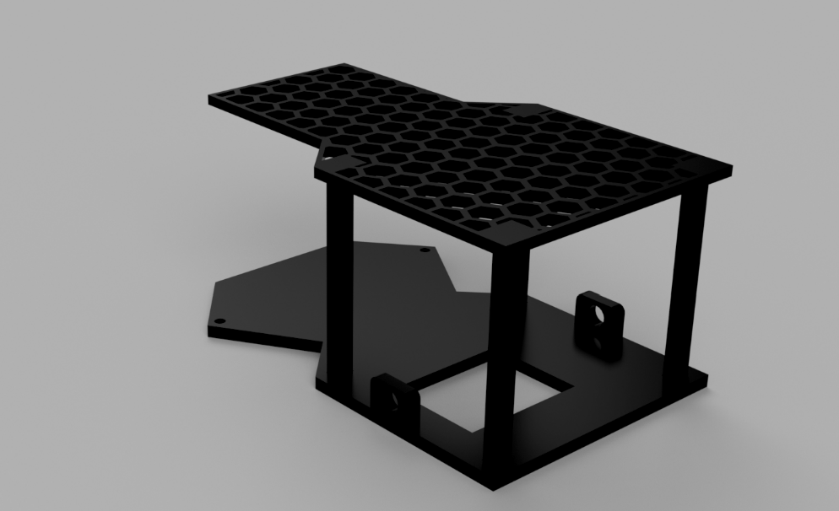
chassis render

As can be seen in the render above, our 2026 WRO chassis consists of two distinct parts, bottom and upper plate (lower and upper deck).
This design is a reflection of multiple constraints and insights gained through iterations. Our main constraint was the maximum width allowed per the 2026. rules which meant that the battery had to be placed on the underside of the top deck, which was not our first choice for the obvious reason of robot’s weight distribution and centre of gravity.
In the first iteration the battery was placed on the lower deck, but we knew from the start that we could not show up with that design as it measured in at 22.6cm in width, so a second chassis was designed (the one that is being described in our journal).
Key changes between the first and second iteration is the battery placement as I already mentioned, but also the maximum width as the new chassis measures in at 12.75cm at its widest point. This helps our turning radius, also the design in itself is much more efficient as less space is left unused, especially in the front half where the LIDAR is placed.
In the second iteration the honeycomb design on the bottom deck was replaced in favour of a solid PETG 3D printed surface for ease of mounting our components, while the upper deck has kept the honeycomb and has also been lengthened to accommodate the battery as well as all the sensors including the RPI and ESP32.

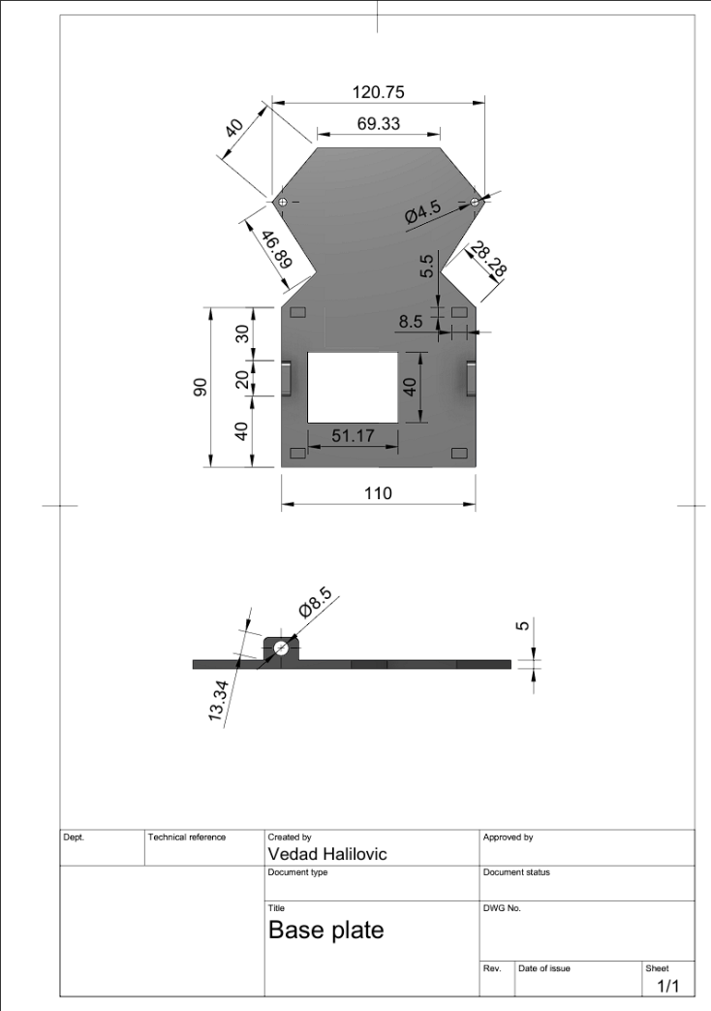
Technical drawing of the base plate with dimensions in 1:2 scale

With the length of 180mm(18cm) and the width of 120.75mm, this base plate fits inside the maximum allowed dimensions per the 2026. rules.
Placement of components was designed to give the robot a 60/40 weight distribution with 60% on the drive axle and 40% on steering wheels.
In the front half we placed our LIDAR on provided standoffs, so it has unobstructed 180-degree view. LIDAR is secured at 4 points using M2 bolts provided by the LIDAR manufacturer.
Under the lidar sits the first spur gear with the steering axles mounted to it using M4 bolts and corresponding nuts. Spur gear is fixed to the base plate using a 4mm stainless steel shaft, with 4mm shaft collars on both sides. Steering hubs that connect wheels to the steering system are connected to steering axles at two point parallel to one another, and to the base plate using the pre-drilled holes and M4 bolts with corresponding nuts. Holes are designed at 4.5mm in diameter due to unavoidable shrinkage associated with 3D printing.
Steering hubs are premade components, and spur gears used in the steering system are repurposed LEGO spur gears. Behind the LIDAR, servo motor is mounted. Spur gear on the servo has half the teeth compared to the spur gear connected to the steering axles. This was done to ensure a more precise system, and to reduce the stress on the servo motor itself.
In the back half of the base plate the drive motor is located on its mount. The drive motor is connected to the axle with spur gears, more precisely a 14 teeth module 2 spur gear with a 20-degree pressure angle. The spur gear is fixed to the motor with a 4mm shaft collar.
The spur gear connected to the axle is a 10 teeth module 2 and also shares the 20-degree pressure angle. This gear is fixed to the drive axle using 4mm shaft collars inside the spur gear.
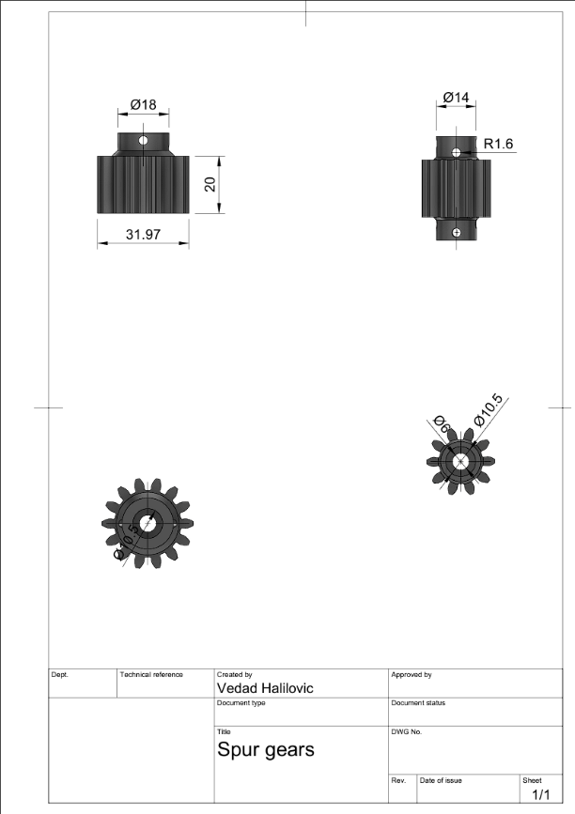
Spur gears drawing

As can be seen in the technical drawing above both gears share the 20mm height, as well as the inside diameter of 10.5mm, even though the shaft collar has an outside diameter of 9mm, due to shrinkage of plastics during 3D printing inner diameter of our gears was set to 10.5mm to compensate for the mentioned shrinkage.
We chose 14:10 ratio because our motor is a high torque model, which means that it comes geared from the manufactuer, and only provides 160rpm on max speed. Testing showed that the best ratio of speed and torque was offered by 14:10 ratio, we also tried 1:2 and 1:3 but during testing we found that this appreoach sacrifices too much torque and that the robot was becoming much less precise because eof this.
Module 2 was chosen because in our very first iteration of the spur gear system with the 2:1 ratio and module 1 gears were skipping a lot and that obviously created issues with movement, as the teeth would slip. That lead us to use module 2 for all other iterations and testing. We used a 20 degree pressure angle from the start, because the higher pressure angle offers stronger teeth(wider base), with a trade-off being louder operation compared to 14.5-degree pressure angle, but as that is not an important factor to us we prioritised the shear strength to avoid teeth snapping, which is also a reson for the 20mm heigth which helps us distribute the load accros the gear.
Below you will find a 3D render of the spur gears which better illustrates the design.

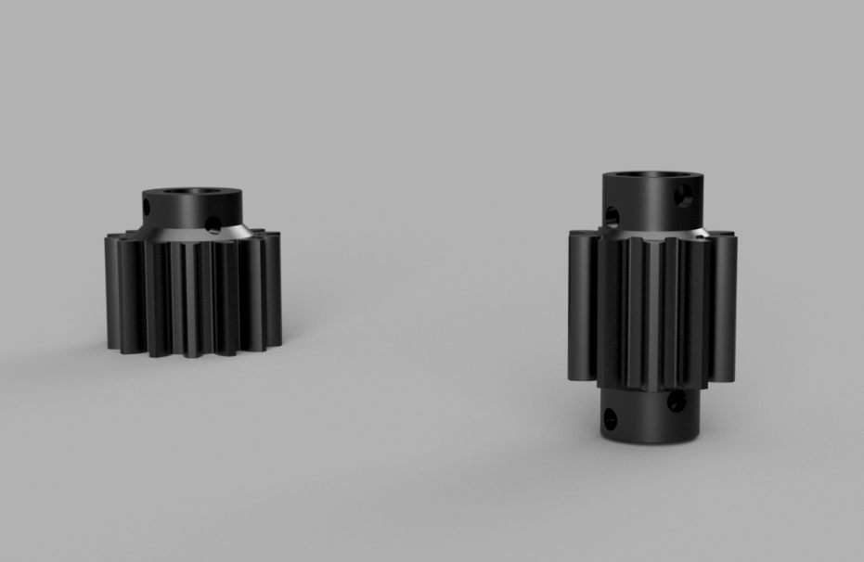
Spur gears render

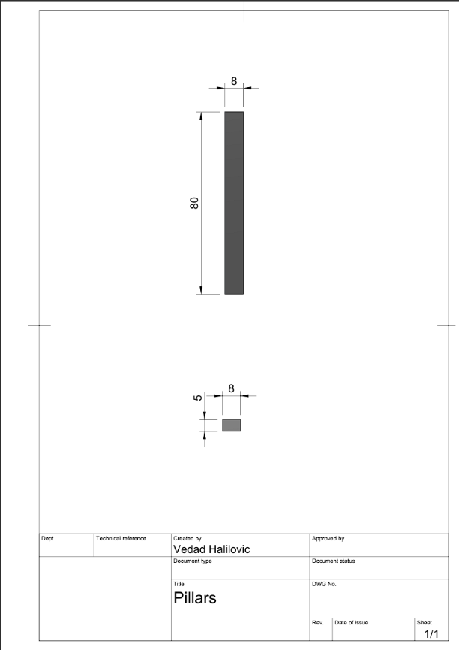
Pillar technical drawing

Four pillars connect the bottom and top deck of our robot. We chose an 85% infill to ensure mechanical stability so that they would not accidentally bend. They sit in the cutouts on the bottom plate, with the same cutouts being found on the top plate as well. Initially we wanted to use a lighter desing with a 20% infill, but as they have to carry the weight of the battery and not just the electronics we opted for a more heavy-duty approach.

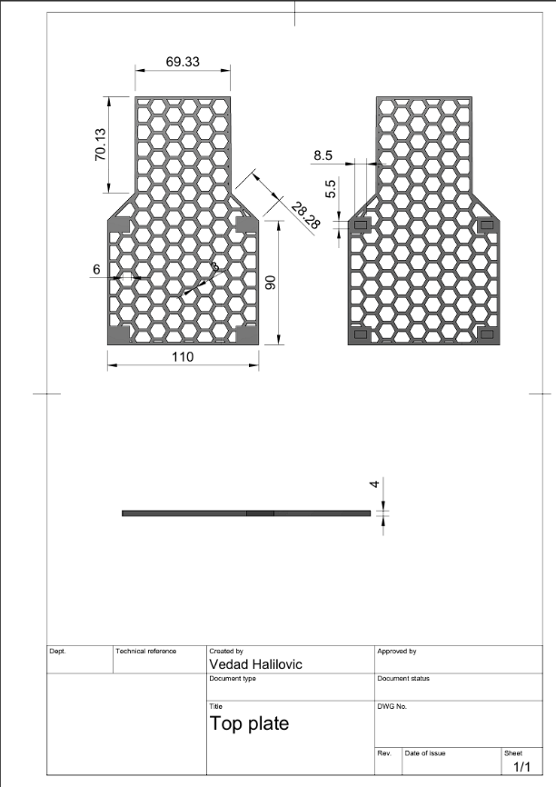
Top plate technical drawing

For our second iteration the top plate has been lenghtened to accommodate both the electronic components and the battery.
We went with a honeycomb design, because it offers weight savings while still giving us enough structural rigidity. For the first iteration of this desing we tried a 2mm thickness, but found that it bends too much and is prone to cracking, so for the second iteration we increased the thickness to 4mm as can be seen on the technical drawing above. For infill we went with 85% because of the dense honeycomb structure. The top plate has an overall length of 18cm, with the widest point coming in with the width of 11cm. The specific shape was chosen for space saving, that is reducing unused space, as the front half is just wide enough to fit a Raspberry Pi, with the back half being wider to accommodate other components, with the breadboard.
In the front half the RPI is placed together with the Pi camera and in the back half ESP32 with the motor driver, MPU and buck converter are placed.

2. Power & sensor architecture
Sensor list:
Name/manufacturer | Model | Use | Current draw
12VDC drive motor | 25GA-370 | Moving the robot | 700mA-1A
Servo motor | Hitec HS-422 | Steering the robot | 600mA-800mA
Pi camera | Raspberry Pi Camera Module 2 | Detecting the obstacle colour | 250mA-300mA
RPI 4 | Model B 8GB | Calculation of navigation data | 1A-3A
RPLIDAR | A1 | Navigation | 600mA
ESP32 | Wroom/DevKit | Management of motors and other sensors | 240mA-500mA
MPU | MPU 6050(6 axis MPU) | Calculation of 90 degree turns | 5mA
Adafruit TB6612 | TB6612FNG | PWM control of 12VDC motor | 10μA

Total system draw ranges from 3.4 – 6.2A depending on the circumstances for instance on idle it is around 3.4, while during the second-round execution 6.2A may be reached.
important to note is that 600-800mA from this sum is the DC motor which does not eat into our buck converter’s power budget.
For our battery we have chosen the GOLDBAT 5000mAh 3s LiPo battery as it offers a 250A continuous current draw, what that means for us is that our voltage does not drop even on startup or under peak loads and the battery stays cool. Only downside to running this battery is the weight penalty with the battery coming in at 429g on its own.
Since the battery has a nominal voltage of 11.1V a buck converter is needed so that the voltage could be stepped down to 5V for other electronics, while the drive motor runs directly off the 11.1V pack.
Buck converter that is being used can output 5-6A with the heatsink that is installed, because we were space constrained, we opted for one high power buck converter rather than two lower power models.
RPI was needed due to our choice of using LIDAR instead of ultrasonic sensors as LIDAR uses USB connection.
For the camera it was not as much of a necessity as it was convenient, because we figured we need the RPI for the LIDAR, we might as well use a Pi camera instead of a standalone module like openMV H7 and similar modules which was also a weight and a space saving measure. All of that combined with RPI’s computational power made it an obvious choice.
TB6612 was chosen because it is compact and much more efficient than older BJT motor drivers with minimal voltage drop due to its use of CMOS. Also, it has a smaller power draw for its own internal components which creates a smaller voltage drop on the ESP32’s 3.3V rail used to power it.

ESP32 is being used to control all the sensors with the exceptions being the Pi camera and LIDAR.
There are multiple reasons for this but the main one being that it was much easier for us to program it in two different codes one on RPI sending the navigation data and ESP32 executing it, that is communicating with said sensors.
Because the 2026 rules dictate a solid rear axle that is no differential drive it was decided to add an IMU, with reasoning that rear wheels spinning at the same speed cause the front wheels to sometimes skip, which produced inconsistencies in 90 degree turns. By adding an IMU this problem was alleviated, with the IMU tracking robot’s yaw and it keeps turning until the robot achieves 90 degrees.
Servo motor on the robot is Hitec HS-422 was chosen mainly for its availability in the region, but also for its torque which was needed to keep the steering smooth on our 1.5kg robot.
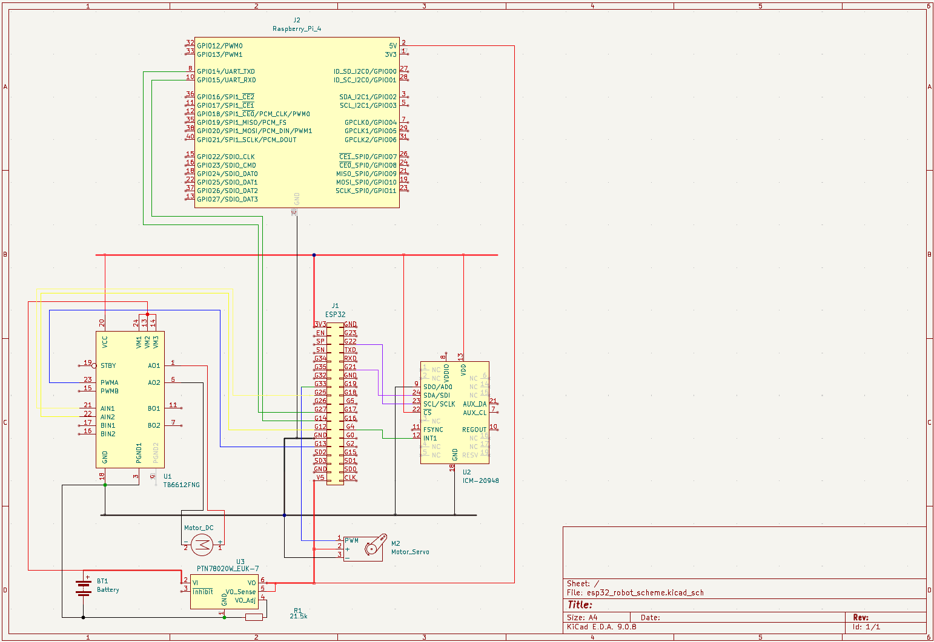
Electrical scheme

In the picture above is presented a wiring diagram/schematic of our robot, except for the camera and LIDAR which we could not obtain in the software that we are using (KiCAD).
As can be seen on the diagram above ESP32 and RPI communicate using TX/RX pins (pins 27, 14 on ESP32). We refrained from directly using TX/RX pins on ESP32, rather we created a virtual serial port/monitor, because we were having issues with inconsistent data transfer using UART, that led us to our unorthodox solution, as a result of which we had to switch to baud rate of 9600 from 115200. In the end the 9600bps did not limit us in any way, furthermore it allowed us to be more flexible with our pins because now we can use almost any pin on our ESP32 for communication with the RPI.
For the MPU we have decided on the I2C protocol for seamless integration with the ESP32, for the calibration we were running a 750 sample for loop as soon as the robot is powered on, during which time the robot remains stationary(both servo and drive motor are disabled) so we can get an accurate calibration with minimal, gyro drift which is further mitigated by using a filter in the updateYaw() function which is further explained in the Software Architecture & Obstacle Strategy section.
But on our second iteration we discovered a function in the library which calibrates the gyro, and also updates all 6-axis, after which we just read the axis that we need. The function in question is mpu.calcGyroOffsets(), and the function for updating the axis is mpu.update().
The TB6612FNG is connected to pins 13, 12, 25(PWMA, AIN2, AIN1). By altering PWM signals on these pins, we control the polarity(direction) and speed of our drive motor. Pins AIN1 and AIN2 control the polarity of the motor, while the PWMA controls the speed which in the code is defined as driveSpeed that is of the integer type.
VCC pin supplies the driver with 3.3V for the logic side that is for powering the transistors, important to note is that the TB6612FNG uses a shared(common) ground between the high voltage and low voltage side.
AO1 and AO2 pins are outputs of the drivers that connect to the motor’s positive and negative terminals.
VM pins supply are connected to 12V, and they supply the motor with power. As can be seen on the diagram above VM pins are connected directly to the battery bypassing the buck converter. For all 12V connections and RPI power line a 0.75mm wire is used to handle large currents without added resistance and heat.
Servo motor is using 5V from the buck converter and is grounded with all the other components. Servo’s signal wire is connected to pin 33 on ESP32. We opted for a 5V servo because it provided enough torque while being significantly lighter than its 12V counterparts.
ESP32 gets its power from the buck converter and steps it down further to 3.3V so it is safe for the IMU and TB6612FNG, it was decided to power these components directly from ESP’s 3.3V rail because the current that they draw is extremely small (measured in microamps).
RPI is powered through its type-C interface using 5V from the buck converter, as all the other components it also has a common ground so as not to cause interference in communication with ESP32 due to difference in potentials.

RPLIDAR is placed at the front of the robot so it has unobstructed 180-degree view of the track, above the LIDAR Pi camera is placed so it could reliably read colours of the obstacles.
MPU is placed on the top deck as far from the drive motor as possible as to limit the EMI, further steps have been taken to limit EMI such as twisting motor’s power lines and having the TB6612FNG on the opposite side of the breadboard also helps alleviate this issue.
Buck converter is placed on the far-right side so its heatsink gets as much cool air over it as possible to be able to passively dissipate the heat from the 5A running through it.
Placement of servo was mainly dictated by the position of the LIDAR with the servo being positioned right behind it.
ESP is placed in the middle of the top deck so as to be close both to the MPU, TB6612FNG and RPI.
- Software Architecture & Obstacle Strategy
Open Challenge – ESP32 Actuation Layer

1. System Overview
The ESP32 is the robot's actuation layer. It receives high-level commands from the Raspberry Pi over UART, drives the motor and steering servo, and uses an MPU6050 gyroscope (IMU) to execute closed-loop 90° turns. The firmware is written in Arduino C++ and is structured around a non-blocking event loop with a dedicated state flag (isTurning) that separates straight-line driving from turn execution.

Architecture Summary
Layer 1 – Communication: HardwareSerial(2) receives commands from RPi at 9600 baud (RX=27, TX=14).
Layer 2 – State Control: isTurning flag gates command parsing; updateYaw() runs every loop iteration.
Layer 3 – Actuation: Servo on GPIO 33 for steering; TB6612-style driver (AIN1/AIN2/PWMA) for motor.

2. Hardware Pin Map

Pin / Bus | GPIO | Role
ledGreen | 2 | Status LED — blinks during startup, solid ON when ready
button_start | 15 | INPUT_PULLUP start button
pwma | 13 | Motor speed (PWM via analogWrite)
ain1 | 25 | Motor direction control A
ain2 | 12 | Motor direction control B
steeringServo | 33 | Steering servo signal
I2C SDA | 21 | MPU6050 data line
I2C SCL | 22 | MPU6050 clock line
UART2 RX | 27 | Receive from Raspberry Pi
UART2 TX | 14 | Transmit to Raspberry Pi

3. State Machine
The firmware operates as a four-state FSM driven by the isTurning flag and the startup sequence:

State | Entry Condition | Actions | Exit Condition
STARTUP | Power on | Blink LED; wait for button; initialise Serial, UART, I2C | Button pressed
CALIBRATE | Button pressed | mpu.calcGyroOffsets() — robot must remain still | Calibration complete
READY / DRIVE | Calibration complete; sends 'a' to RPi | Parse UART commands; apply steering angle; drive at driveSpeed | Receives 'l', 'r', 'n', or 'm'
TURNING | startTurn() called | Reduced speed; full servo lock; checkTurnProgress() each loop | yaw reaches targetYaw; sends 'h' to RPi

The isTurning flag is the central gate of the FSM. While isTurning is true, incoming UART commands are ignored completely — this prevents a new steering angle arriving mid-turn from interfering with the gyro-controlled manoeuvre.

4. IMU Integration — updateYaw()
The MPU6050 is used exclusively for yaw (Z-axis rotation) tracking. It is updated on every loop iteration to maximise angular resolution during turns:

void updateYaw() {
mpu.update();
yaw = mpu.getGyroAngleZ(); // integrated gyro angle in degrees
static float lastPrintedYaw = 0;
if (abs(yaw - lastPrintedYaw) > 0.5) { // only print on meaningful change
Serial.print("Current Yaw: ");
Serial.println(yaw);
lastPrintedYaw = yaw;
}
}

mpu.getGyroAngleZ() returns an accumulated (integrated) angle — it measures rotation relative to the heading at power-on, not absolute compass bearing. This is ideal for 90° turn control because only the change in heading matters. The 0.5° print threshold prevents the debug serial from being spammed on every loop while still logging every meaningful heading change. Gyro offsets are calculated once at startup via mpu.calcGyroOffsets(true) with the robot stationary, which removes the systematic drift component from the integration.

5. Turn Execution Algorithm

5.1 Turn Initiation — startTurn()

void startTurn() {
isTurning = true;
driveForward(driveSpeed - 35); // reduce speed: 130 - 35 = 95 PWM
if (turnDirection == 1) steeringServo.write(40); // full left lock
else if (turnDirection == -1) steeringServo.write(150); // full right lock
}

Speed is reduced by 35 PWM counts during turns to improve gyro tracking accuracy and reduce centrifugal forces on the chassis. The servo is immediately set to full lock (40 for left, 150 for right) to begin rotating as aggressively as possible at the start of the corner.

5.2 Proportional Turn Control — checkTurnProgress()
Rather than holding full servo lock throughout the entire turn, the algorithm applies a proportional correction that gradually straightens the wheels as the robot approaches its target heading. This reduces overshoot:

void checkTurnProgress() {
if (turnDirection == 1) { // left turn
if (yaw > targetYaw) { // still turning
int turnAngle = round(minL - (k * (yaw - targetYaw)));
steeringServo.write(constrain(turnAngle, 40, 80));
} else { turnComplete = true; }
} else if (turnDirection == -1) { // right turn
if (yaw < targetYaw) {
int turnAngle = round(minR - (k * (yaw - targetYaw)));
steeringServo.write(constrain(turnAngle, 110, 150));
} else { turnComplete = true; }
}
}

The control law for each direction is explained below:

Parameter | Value | Meaning
k | 0.33 | Proportional gain — controls how quickly the servo straightens as the target approaches
minL | 76.0 | Left servo near-neutral angle — the angle the servo approaches as error → 0
minR | 114.0 | Right servo near-neutral angle — symmetric to minL around the centre (96°)
constrain left | [40, 80] | Hard limits the left-turn servo: never beyond full lock, never past near-neutral
constrain right | [110, 150] | Hard limits the right-turn servo: symmetric safety bounds

Left turn example: targetYaw = yaw_initial - 90. While yaw > targetYaw, the error (yaw - targetYaw) is positive and shrinking. turnAngle = 76 - 0.33 * error: when error is large the angle goes below 76 (more leftward lock); as error shrinks toward zero, turnAngle approaches 76 (near-neutral). The result is a smooth steering unwind that reduces the chance of the robot swinging past the target heading.
Right turn example: targetYaw = yaw_initial + 90. While yaw < targetYaw, (yaw - targetYaw) is negative, so -k*(negative) is positive: turnAngle = 114 + 0.33 * |error|. When error is large, angle goes toward 150 (full right lock); as error shrinks, it approaches 114 (near-neutral). Constrained to [110, 150].

6. Command Protocol
All communication uses newline-terminated ASCII strings at 9600 baud over HardwareSerial(2):

Direction | Command | Action
RPi → ESP | Integer (e.g. '-14') | Map to servo range [40–150] and drive forward at driveSpeed
RPi → ESP | 'l' | Left 90° turn: targetYaw = yaw - 90, turnDirection = 1
RPi → ESP | 'r' | Right 90° turn: targetYaw = yaw + 90, turnDirection = -1
RPi → ESP | 'n' | Left 45° turn (reserved for Round 2 obstacle avoidance)
RPi → ESP | 'm' | Right 45° turn (reserved for Round 2 obstacle avoidance)
RPi → ESP | 't' | LiDAR error: stop motors for 1.1 seconds, then resume
RPi → ESP | 'e' | End of run: wait 500 ms, stop all motors
ESP → RPi | 'a' | Ready signal: calibration complete, RPi may begin scanning
ESP → RPi | 'h' | ACK: turn complete, RPi may resume LiDAR-guided driving

Steering integers are received in the range [-90, 90] and remapped to servo positions using Arduino's map() function: map(incomingAngle, -90, 90, 40, 150). The servo neutral (96) sits near the midpoint of this range (95), with the 1-degree offset accounting for mechanical centre trim. Commands 'n' and 'm' (45° turns) are implemented and tested but not invoked by the Round 1 RPi code — they are pre-built for Round 2 obstacle avoidance.

7. Startup & Calibration Sequence

void setup() {
pinMode(button_start, INPUT_PULLUP);
while (button_start == HIGH) { // blink LED while waiting
digitalWrite(ledGreen, HIGH); delay(500);
digitalWrite(ledGreen, LOW); delay(500);
}
delay(1000);
Serial.begin(115200); // debug USB serial
mySerial.begin(9600, SERIAL_8N1, 27, 14); // RPi UART
Wire.begin(21, 22);
mpu.begin();
mpu.calcGyroOffsets(true); // robot must be stationary
steeringServo.attach(33);
stopAll();
steeringServo.write(96); // centre steering
digitalWrite(ledGreen, HIGH); // solid ON = ready
mySerial.println("a"); // notify RPi
}

The startup sequence is deliberately ordered: the button gate comes first so the operator can position the robot before any initialisation begins. The gyro calibration (mpu.calcGyroOffsets) takes several seconds and requires the robot to be completely stationary — placing it after the button press guarantees this. The LED blinks during the wait and turns solid when ready, giving the operator a clear visual status. The 'a' message is the final action, signalling the Raspberry Pi that the ESP is calibrated and commands may begin.

8. Motor & Servo Control

void driveForward(int speed) {
digitalWrite(ain1, LOW);
digitalWrite(ain2, HIGH); // sets forward direction
analogWrite(pwma, speed); // PWM speed control (0-255)
}

void stopAll() {
analogWrite(pwma, 0);
digitalWrite(ain1, LOW);
digitalWrite(ain2, LOW); // both LOW = coast/brake
}

The motor driver is controlled via two direction pins (AIN1, AIN2) and one PWM speed pin (PWMA). Forward direction is AIN1=LOW, AIN2=HIGH. stopAll() sets PWM to 0 and both direction pins LOW, which puts the driver in a coast state. The normal driving speed is 130/255 PWM. During turns this is reduced to 95/255 via driveSpeed - 35, improving yaw tracking accuracy.

Servo Value | Physical Meaning
40 | Full left lock (maximum turn)
80 | Near-neutral left (used as turn completion boundary)
96 | Mechanical centre / straight ahead
114 | Near-neutral right (used as turn completion boundary)
150 | Full right lock (maximum turn)

9. Edge Case Handling

9.1 Turn Interrupt Protection
The UART read block is guarded by !isTurning. Any steering or turn command that arrives while a turn is in progress is discarded. This ensures the gyro-controlled manoeuvre completes cleanly without interference from LiDAR updates that may still be arriving from the RPi.

9.2 LiDAR Error Recovery — 't' Command
When the Raspberry Pi detects an RPLidar exception in safe_scans(), it sends 't' to the ESP before attempting recovery. The ESP responds by stopping the motors for 1.1 seconds. This prevents the robot from driving blind during the sensor restart window, which typically takes 0.5–1.0 seconds.

9.3 Servo Constraining During Turns
The proportional turn formula can theoretically produce values outside the physical servo range. The constrain() calls — [40, 80] for left and [110, 150] for right — hard-limit the output regardless of the gain k or the size of the yaw error, protecting the servo from out-of-range commands.

9.4 Post-Turn Settling
After a turn completes, the sequence is: servo to centre (96) → isTurning = false → 500 ms delay → send 'h' → stopAll() → 1000 ms delay. The 500 ms before sending 'h' ensures the robot has physically stopped rotating before the RPi resumes sending steering corrections. The 1000 ms stop after 'h' gives the RPi time to clean its LiDAR input buffer before the robot starts moving again.

10. Testing & Tuning Process

10.1 Gyro Calibration Verification
- Robot placed on flat surface, powered on, button pressed.
- USB serial monitor observed for 'MPU Ready and Calibrated!' message.
- Robot left stationary for 30 seconds post-calibration; yaw drift measured at < 0.3°/min, confirming offsets are valid.

10.2 Turn Accuracy Tuning
- k = 0.33 chosen by running turns and measuring final heading with a protractor. Lower k caused overshoot; higher k caused the servo to straighten too early and undershoot.
- minL = 76 and minR = 114 were tuned by observing the servo position at which the robot tracked straight after a turn. They are symmetric around 96 (mechanical centre).
- driveSpeed - 35 (95 PWM) was the lowest speed at which the robot reliably completed turns within the mat boundaries while still rotating fast enough to not stall.

10.3 Metrics Used to Validate Performance
Metric | How Measured | Target
Turn heading accuracy | Protractor after 12-turn run | < 5° cumulative yaw error
Turn completion time | Stopwatch from 'l'/'r' sent to 'h' received | < 3 seconds per turn
Gyro drift over 3 laps | Read final yaw after 12 turns with no movement | < 5° drift
Motor response latency | Oscilloscope on PWMA vs UART RX edge | < 10 ms
LiDAR recovery success rate | 't' command test: cut LiDAR USB mid-run | >= 4/5 recoveries

11. Annotated Source Code
The full ESP32 firmware is presented below in logical blocks with explanatory notes at key decision points.

11.1 Includes & Global State
#include <Arduino.h>
#include <ESP32Servo.h>
#include <Wire.h>
#include <MPU6050_tockn.h>
#include <cmath>

HardwareSerial mySerial(2); // UART2: RX=27, TX=14
Servo steeringServo;
MPU6050 mpu(Wire);

const double k = 0.33; // proportional turn gain
const double minL = 76.0; // left servo near-neutral
const double minR = 114.0; // right servo near-neutral

int driveSpeed = 130; // normal drive PWM (0-255)
float yaw = 0; // accumulated gyro angle (degrees)
bool isTurning = false; // FSM gate flag
float targetYaw = 0; // heading to reach during turn
int turnDirection = 0; // 1 = left, -1 = right

All mutable state is kept in global variables so it persists across loop() iterations. isTurning is the single flag that separates DRIVE state from TURNING state — it is read in loop() on every iteration.

11.2 setup()

void setup() {
digitalWrite(ledGreen, LOW);
pinMode(button_start, INPUT_PULLUP);
while (button_start == HIGH) { // blink while waiting for button
digitalWrite(ledGreen, HIGH); delay(500);
digitalWrite(ledGreen, LOW); delay(500);
}
delay(1000); // debounce + operator ready time
Serial.begin(115200); // USB debug serial
mySerial.begin(9600, SERIAL_8N1, 27, 14);
Wire.begin(21, 22); // I2C for MPU6050
mpu.begin();
mpu.calcGyroOffsets(true); // robot must be stationary here
steeringServo.attach(33);
stopAll();
steeringServo.write(96); // centre wheels
digitalWrite(ledGreen, HIGH); // solid = ready
mySerial.println("a"); // signal RPi: calibration complete
}

The gyro calibration is the most time-sensitive part of setup — it must happen with the robot completely stationary. Placing it after the button press guarantees this, since the operator has just finished positioning the robot. Sending 'a' as the very last action ensures the RPi never starts transmitting commands before the ESP is fully initialised.

11.3 loop()
void loop() {
updateYaw(); // always update IMU first
if (mySerial.available() > 0 && !isTurning) {
String data = mySerial.readStringUntil('\n');
data.trim();
if (data.length() > 0) {
if (data == "l") {
targetYaw = yaw - 90.0;
turnDirection = 1;
startTurn(); }
else if (data == "r") {
targetYaw = yaw + 90.0;
turnDirection = -1;
startTurn(); }
else if (data == "n") {
targetYaw = yaw - 45.0;
turnDirection = 1;
startTurn(); }

else if (data == "m") {
targetYaw = yaw + 45.0;
turnDirection = -1;
startTurn(); }
else if (data == "t") {
stopAll();
delay(1100); }
else if (data == "e") {
delay(500);
stopAll(); }
else { // numeric steering angle from PD controller
int servoAngle = map(data.toInt(), -90, 90, 40, 150);
steeringServo.write(servoAngle);
driveForward(driveSpeed);
}
}
}
if (isTurning) checkTurnProgress();
}

updateYaw() runs unconditionally at the top of every loop iteration — even during turns — to keep the yaw accumulation as fine-grained as possible. The UART block is skipped when isTurning is true, preventing any incoming command from overriding the turn. The else branch at the bottom handles numeric angles: map() linearly converts [-90, 90] to [40, 150] servo counts and the motor drives at full normal speed.

11.4 checkTurnProgress()
void checkTurnProgress() {
bool turnComplete = false;
if (turnDirection == 1) { // left turn
if (yaw > targetYaw) { // not yet reached target
int a = round(minL - (k * (yaw - targetYaw)));
steeringServo.write(constrain(a, 40, 80));
} else { turnComplete = true; }
} else if (turnDirection == -1) { // right turn
if (yaw < targetYaw) {
int a = round(minR - (k * (yaw - targetYaw)));
steeringServo.write(constrain(a, 110, 150));
} else { turnComplete = true; }
}
if (turnComplete) {
steeringServo.write(96); // centre wheels
isTurning = false;
delay(500); // let robot finish rotating
turnDirection = 0;
mySerial.println("h"); // ACK to RPi
stopAll();
delay(1000); // full stop before next straight
}
}

The proportional unwind: for a left turn, (yaw - targetYaw) starts large (~90) and shrinks to 0. The servo angle starts near 40 (full lock) and rises toward minL=76 as the turn completes. The constrain() ensures the formula never commands an illegal angle. On completion, the two-stage stop (500 ms then 'h' then 1000 ms) creates a clean handoff: the robot is physically stationary before the RPi is told to resume, and stays stationary long enough for the RPi to restart the LiDAR scan loop.

11.5 driveForward() & stopAll()
void driveForward(int speed) {
digitalWrite(ain1, LOW);
digitalWrite(ain2, HIGH); // forward direction
analogWrite(pwma, speed);
}

void stopAll() {
analogWrite(pwma, 0);
digitalWrite(ain1, LOW);
digitalWrite(ain2, LOW); // stop
}

Motor direction is set by the AIN1/AIN2 combination. Both LOW is the coast/brake state — the driver de-energises the motor rather than actively braking. Speed is controlled via 8-bit PWM on PWMA; 130/255 (~51% duty) is the cruising speed chosen to balance pace and LiDAR tracking stability.

Software Architecture & Obstacle Strategy
Open Challenge – Round 1

1. System Overview
The robot's control software runs on a Raspberry Pi and orchestrates two primary subsystems: a 360° LiDAR sensor (RPLidar) for spatial awareness, and a serial UART link to an ESP microcontroller that drives the motors and servo. The software is written in Python and follows a reactive, event-driven architecture organised into three logical layers. Key spatial constants: max LiDAR distance inside the walls ≈ 1000 mm; max distance across the open mat ≈ 3000 mm.

Architecture Summary
Layer 1 – Perception: RPLidar continuously scans the environment and yields distance/angle tuples.
Layer 2 – Decision: PD controller computes steering corrections; threshold logic detects open walls (turn triggers).
Layer 3 – Actuation: Commands are serialised as ASCII frames and sent to the ESP via UART.

2. State Machine
The program operates as a finite state machine (FSM) with four clearly defined states:

State | Trigger / Entry Condition | Action | Exit Condition
INIT | Program start | Clean LiDAR port, hardware reset, health check | First valid scan received
DIRECTION DETECT | INIT complete | Scan walls left & right; compare average distances | avgl ≥ 1000 mm OR avgr ≥ 1000 mm
LANE FOLLOW | After each turn completes (skreno = False) | PD correction sent every scan cycle | Open wall detected again
TURN | avgl ≥ 1000 or avgr ≥ 1000 | Stop LiDAR, send 'l'/'r' to ESP, wait for 'h' ACK | count_turns == 12 → END

The boolean flag skreno (Bosnian: 'turned') acts as the handshake gate between the Raspberry Pi and the ESP. It is set True before every turn request and cleared only when the ESP replies with the character 'h', confirming the manoeuvre is complete. This prevents the LiDAR scan loop from resuming prematurely.

3. Lane-Following Algorithm (PD Controller)

3.1 Sensor Cone Geometry
Rather than using a single point measurement, the algorithm averages all LiDAR returns that fall within two angular cones, one per side of the robot:

Side | Angular Range | Rationale
Left | 345°–360° + 0°–15° | Spans the 0°/360° discontinuity; captures the full left wall zone
Right | 165°–195° | Centred on 180° (rear-facing axis); captures the right wall zone

Averaging multiple readings per cone suppresses noise from surface reflections and moving obstacles. The count variable (initialised to 1) also prevents division-by-zero when a side returns no valid readings.

3.2 PD Control Law
The error signal and output are computed as follows:

error = avgr - avgl # positive → too close to right wall
res = kp * error + kd * (error - last_error) # PD output (degrees)
last_error = error # store for next derivative term

The result res is clamped to [−90, +90] degrees inside send_command() before being transmitted. Both gains were tuned empirically:

Parameter | Value | Effect & Tuning Rationale
kp | 0.05 | Proportional gain. Kept low because wall distances inside the WRO mat can be 500–1000 mm; a larger kp caused oscillation.
kd | 0.0015 | Derivative gain. Damps overshoot by reacting to the rate of change of the error. Set to ≈3% of kp to avoid amplifying LiDAR jitter.
offset | 0 | Static lateral offset (mm). Set to 0 for centred tracking; can be changed to bias the robot toward either wall.

The derivative term consistently uses (error − last_error) across all branches, giving a positive output when the error is growing and a negative output when it is shrinking, which correctly damps overshoot in both the straight and post-turn recovery phases.

4. Turn Detection & Obstacle Strategy

4.1 Open-Wall Detection
A turn is triggered when the average wall distance on either side exceeds a threshold, indicating the robot has reached a corner of the mat where there is no wall:

Threshold Logic
Left turn: avgl ≥ 1000 mm → send 'l' to ESP, increment count_turns
Right turn: avgr ≥ 1000 mm → send 'r' to ESP, increment count_turns

The 1000 mm threshold was chosen because the maximum LiDAR distance when a wall is
present is ~1000 mm. Any reading at or above this means the sensor is looking past a
corner into open space — the full mat spans up to 3000 mm — reliably indicating a turn.

4.2 Three-Lap Completion
WRO Future Engineers requires three complete laps (12 × 90° turns). The counter count_turns is incremented on every turn event. When count_turns reaches 12, the inner loop breaks and the program sends the 'e' (end) command to halt the robot.

Direction is locked after the first detected turn. If the first open wall is on the left the robot is declared a left-turner for all 12 remaining turns, and vice versa. This prevents the algorithm from misidentifying a corner on the far side of the mat as an instruction to change chirality mid-run.

5. Raspberry Pi ↔ ESP Communication Protocol
All messages are ASCII strings terminated by a newline (\n) sent at 9600 baud over UART (/dev/serial0). The protocol is minimal and deterministic:

Direction | Frame Format | Meaning
RPi → ESP | <integer>\n (e.g. '−14\n') | Steering angle in degrees; clamped to [−90, +90]
RPi → ESP | 'l'\n | Execute left 90° turn
RPi → ESP | 'r'\n | Execute right 90° turn
RPi → ESP | 'e'\n | Stop; end of run
RPi → ESP | 't'\n | LiDAR error notification; ESP holds position during sensor recovery
ESP → RPi | 'h'\n | ACK: turn complete, ready to resume

6. Edge Case Handling

6.1 LiDAR Communication Errors
The safe_scans() generator wraps the LiDAR scan loop in a try/except block. On any RPLidarException the generator:
- Calls lidar.stop() and waits 500 ms
- Calls lidar.clean_input() and waits a further 500 ms
- Restarts the scan iterator automatically — the outer while True ensures the scan loop never permanently exits due to a transient USB glitch

6.2 LiDAR Initialisation Race Condition
The get_clean_lidar() function performs a controlled startup sequence to avoid the common RPLidar firmware lockup:
- Forces DTR low on the raw serial port to reset the device
- Flushes both the input and output buffers before handing control to the rplidar library
- Issues a hardware reset command and polls get_health() to confirm the sensor is ready
- Falls back to a direct reconnect if the hardware reset command raises an exception

6.3 Division-by-Zero in Distance Averaging
Both countl and countr are initialised to 1 (not 0) before each scan, so the division avgX = sumX / countX is always safe even when no LiDAR returns fall inside a cone during a particular scan cycle.

6.4 Serial Timeout & Blocking Reads
The serial port is opened with timeout=1 second. The while skreno loop that waits for the 'h' acknowledgement therefore blocks for at most 1 second per readline() call, preventing an infinite hang if the ESP fails to respond.

7. Testing & Tuning Process

7.1 Methodology
All tuning was performed on the physical WRO 2025 mat. The following iterative process was used:
- Step 1 – Set kd = 0, tune kp alone until the robot tracks the centreline without steady-state offset
- Step 2 – Reintroduce kd and increase until overshoot is visibly reduced without adding jitter
- Step 3 – Adjust turn thresholds (1000 mm / 1700 mm) by running the robot into each corner and reading the logged avgL/avgR values printed to the terminal
- Step 4 – Verify 12-turn count by observing count_turns in terminal output during a full 3-lap dry run

7.2 Metrics Used to Validate Performance

Metric | How Measured | Target / Acceptance
Lateral offset from centre | Tape measure at mid-straight after each lap | < 5 cm average deviation
Turn detection reliability | Count false triggers per 12-turn run | 0 false triggers
Turn completion ACK time | Serial terminal timestamps | < 3 seconds per turn
Full-run completion rate | Number of clean 3-lap runs / total attempts | ≥ 4/5 runs completed
LiDAR restart frequency | Count of 'Lidar greska' prints per run | < 2 per run

8. Code Modularity Summary

Function / Block | Responsibility | Inputs | Outputs
get_clean_lidar() | Safe LiDAR initialisation with reset & health check | PORT_LIDAR constant | Initialised RPLidar object
safe_scans(lidar) | Fault-tolerant scan generator; auto-restarts on error | RPLidar object | Scan iterator (yields scan lists)
send_command(angle) | Encode & transmit steering angle over UART | Float (degrees) | Serial frame to ESP
turning(lorr) | Send directional turn or end command over UART | String: 'l', 'r', or 'e' | Serial frame to ESP
Direction detect loop | First-scan phase; determines turn chirality | LiDAR scan data | Sets turnl / turnr flag
Lane-follow loop (turnl) | Left-hand traffic: PD control + left-turn trigger | LiDAR scan data, skreno | Steering commands, turn events
Lane-follow loop (else) | Right-hand traffic: PD control + right-turn trigger | LiDAR scan data, skreno | Steering commands, turn events

9. Software Flow Diagram
The diagram below illustrates the complete execution flow of the Round 1 software:

Execution Flow (text representation)
START
└─► get_clean_lidar() → Serial port open
└─► DIRECTION DETECT LOOP (safe_scans)
├─ PD correction → send_command(res)
├─ avgl ≥ 1000 → turning('l') → wait ACK → turnl = True → BREAK
└─ avgr ≥ 1000 → turning('r') → wait ACK → turnr = True → BREAK
└─► LANE-FOLLOW LOOP (safe_scans, 12-turn limit)
├─ [TURN detected] → lidar.stop() → turning() → wait ACK → count_turns++
│ └─ count_turns == 12 → BREAK
└─ [STRAIGHT] → PD correction → send_command(res)
└─► turning('e') → lidar.disconnect() → END

10. Annotated Source Code
The full Round 1 program is presented below in logical blocks. Explanatory notes appear between blocks where the rubric criteria — algorithm justification, state machine rationale, edge-case handling — benefit from direct reference to the code.

10.1 Imports & Configuration
import rplidar
import serial
import time

PORT_LIDAR = "/dev/ttyUSB0"
PORT_SERIAL = "/dev/serial0"
BAUDRATE = 9600

lidar = rplidar.RPLidar(PORT_LIDAR, 256000)
ser = serial.Serial(PORT_SERIAL, BAUDRATE, timeout=1)
time.sleep(2)

The LiDAR communicates at 256 000 baud over USB; the ESP link uses 9 600 baud over the Pi's hardware UART. The 2-second sleep allows both devices to finish booting before commands are issued. timeout=1 on the serial port ensures readline() never blocks permanently if the ESP stalls.

10.2 PD Controller Constants
kp = 0.05 # proportional gain
kd = 0.0015 # derivative gain
offset = 0 # lateral wall bias (mm)
last_error = 0 # stores previous error for derivative term

kp and kd were tuned empirically on the physical mat (see Section 7). offset is a static lateral bias — positive shifts the robot toward the right wall, negative toward the left. last_error is initialised to 0 and updated every scan cycle.

10.3 LiDAR Initialisation — get_clean_lidar()
def get_clean_lidar():
raw_ser = serial.Serial(PORT_LIDAR, baudrate=256000, timeout=1)
raw_ser.setDTR(False) # pull DTR low — forces hardware reset on USB bridge
time.sleep(0.1)
raw_ser.reset_input_buffer() # flush stale bytes left from previous run
raw_ser.reset_output_buffer()
raw_ser.close()
obj = rplidar.RPLidar(PORT_LIDAR)
try:
obj.reset() # send firmware reset command to sensor
time.sleep(2) # wait for sensor to reboot fully
obj.get_health() # confirm sensor reports OK before returning
return obj
except rplidar.RPLidarException:
obj.disconnect()
return rplidar.RPLidar(PORT_LIDAR) # fallback: cold reconnect

Opening the port and pulling DTR low resets the USB-UART bridge before the rplidar library takes ownership — this prevents a lockup where the sensor is left mid-scan from a previous run. The health check confirms the sensor is responsive before scanning begins. If the firmware reset throws an exception, the function falls back to a clean reconnect rather than crashing.

10.4 Fault-Tolerant Scan Generator — safe_scans()
def safe_scans(lidar):
while True: # infinite retry loop
try:
for scan in lidar.iter_scans(): #iter_scans() calls start() internally
yield scan
except rplidar.RPLidarException as e:
print(f"Lidar greska: {e}, ciscenje i restart")
try:
lidar.stop()
time.sleep(0.5)
lidar.clean_input() # flush corrupted bytes from buffer
time.sleep(0.5)
except:
pass #ignore secondary errors during cleanup

safe_scans() is a Python generator that wraps iter_scans() in an infinite retry loop. On any RPLidarException it flushes the sensor buffer and waits before retrying. Because iter_scans() internally calls start_motor() and start() each time it is entered, the retry is self-healing without needing an explicit lidar.start() call. The bare except on the cleanup block ensures a secondary failure during recovery does not crash the program.

10.5 Communication Functions
def send_command(angle):
angle = int(max(-90, min(90, angle))) # hard-clamp to servo range
ser.write(f"{angle}\n".encode())

def turning(lorr):
ser.write(f"{lorr}\n".encode()) # sends 'l', 'r', or 'e'

send_command() clamps the PD output to [−90, +90] before transmission, protecting the servo from out-of-range values during large transient errors (e.g. immediately after a turn). turning() sends single-character directional commands using the same newline-delimited ASCII protocol.

10.6 Sensor Cone Geometry Variables
minl1, maxl1 = 345, 360 # left cone — upper arc
minl2, maxl2 = 0, 15 # left cone — lower arc (spans the 0°/360° seam)
minr, maxr = 165, 195 # right cone — centred on 180° (robot rear)

The left cone is split into two arcs to handle the 0°/360° discontinuity in the LiDAR angle output cleanly. The right cone is centred on 180° and spans 30° total to collect enough returns per scan for a stable average even at speed.

10.7 Direction Detection — State: DIRECTION DETECT
lidar.stop()
time.sleep(1)
lidar.clean_input() # discard stale data before first scan
time.sleep(0.5) # extra settling time for the USB buffer

for scan in safe_scans(lidar):
suml = 0 ; countl = 1 # reset per scan; countl=1 prevents division-by-zero
sumr = 0 ; countr = 1
for (_, angle, distance) in scan:
if (angle > minl1 and angle < maxl1) or (angle > minl2 and angle < maxl2):
suml += distance ; countl += 1
if angle > minr and angle < maxr:
sumr += distance ; countr += 1
avgr = sumr / countr
avgl = suml / countl
error = avgr - avgl # positive = closer to left wall, steer right
res = kp * error + kd * (error - last_error) # PD control law
last_error = error
send_command(res)

The robot steers and averages distances simultaneously every scan cycle. error = avgr − avgl: when the robot drifts left the right wall appears farther away, producing a positive error and a rightward correction. The derivative term (error − last_error) damps overshoot by reducing the output as the error shrinks.

if avgl >= 1000: # left wall gone — open corner detected
lidar.stop()
turnl = True # lock chirality to left for all 12 turns
turning('l')
count_turns += 1
while skreno == True: # block until ESP confirms turn complete
line = ser.readline().decode('utf-8').strip()
if line == "h":
skreno = False
lidar.clean_input()
time.sleep(0.2) # brief pause to let robot clear the corner
break
if avgr >= 1000: # mirror logic for right chirality

Any average distance at or above 1000 mm means the sensor is reading into open space — the maximum distance with a wall present is ~1000 mm, while the open mat extends up to 3000 mm. The robot locks its chirality (turnl/turnr flag) for the entire run. The skreno handshake guarantees scanning does not resume until the ESP has finished executing the turn.

10.8 Lane-Follow Loop — Left Chirality
if turnl == True:
while count_turns < 12: # outer loop: one iteration per straight+turn
skreno = True
for scan in safe_scans(lidar): # re-enters iter_scans cleanly each turn
# (same cone accumulation)
if avgl >= 1000:
lidar.stop()
turning("l")
count_turns += 1
while skreno == True:
line = ser.readline().decode('utf-8').strip()
if line == "h":
skreno = False
lidar.clean_input()
skreno = True
avgl = 0 # zero average to prevent immediate re-trigger
time.sleep(0.2) # settle before next scan cycle
break # exit for-loop; while re-enters safe_scans
else:
error = avgr - avgl - offset
res = kp * error + kd * (error - last_error)
last_error = error
send_command(res)

The outer while loop is the key structural change from the previous version. Instead of a single long for-loop with a break-on-12 check inside, each iteration of while count_turns < 12 calls safe_scans() fresh — re-entering iter_scans() and restarting the LiDAR scan cleanly after every turn. When a corner fires, avgl is zeroed before breaking so the very first scan of the next while iteration cannot falsely re-trigger the turn. The 0.2 s sleep gives the robot time to physically clear the corner.

10.9 Lane-Follow Loop — Right Chirality
else:
while count_turns < 12:
skreno = True
for scan in safe_scans(lidar):
# (same accumulation)
if avgr >= 1000:
lidar.stop()
turning("r")
count_turns += 1
# (same skreno handshake)
skreno = True
avgr = 0 # reset to prevent re-trigger
time.sleep(0.2)
break
else:
error = avgr - avgl + offset
res = kp * error + kd * (error - last_error)
last_error = error
send_command(res)

Structurally identical to the left loop. avgr is zeroed after each turn for the same re-trigger protection. The offset sign is flipped: a positive offset increases the error term, biasing the robot toward the right wall, consistent with the right-hand circuit geometry.

10.10 End of Run
turning("e") # stop command to ESP
lidar.disconnect() # release USB port cleanly

After the 12th turn ACK the program sends 'e' to halt the robot in the final quadrant, then disconnects the LiDAR to release the USB port.

Software Architecture & Obstacle Strategy
Obstacle Challenge – Round 2

1. System Overview
The Round 2 software fuses three sensing modalities — a 360° LiDAR for wall distance, a Raspberry Pi Camera for colour block detection, and a gyroscope (on the ESP32) for turn confirmation — into a unified control pipeline. The architecture extends the Round 1 PD lane-follower with a computer vision layer that dynamically biases the steering offset to navigate around red and green obstacle blocks. The camera is used in a burst mode — captured only at the start of each straight segment rather than continuously — to avoid blocking the real-time LiDAR scan loop.

Three-Layer Fusion Architecture
Layer 1 – Perception: LiDAR (wall distances) + Picamera2 (block colour, side, zone).
Layer 2 – Decision: PD controller + block-derived offset (prva_kocka/druga_kocka).
Layer 3 – Actuation: Steering angle + turn commands sent to ESP32 via UART.

2. State Machine

State | Entry Condition | Actions | Exit Condition
INIT | Program start | LiDAR reset; camera warm-up (1 s); initial scan_frame(); direction determined | Blocks visible OR no blocks → LiDAR fallback
DIRECTION DETECT (camera) | Blocks detected in initial frame | Block side determines turnl/turnr; obilazenje() sets first offsets | turnl or turnr flag set
DIRECTION DETECT (LiDAR) | No blocks in initial frame | LiDAR wall scan + PD correction until avgl/avgr >= 1000 | First open wall detected
LANE FOLLOW + AVOIDANCE | Direction locked | PD + block offset; camera burst per straight (lap 1 only); gyro proximity switching | count_turns == 12
END | count_turns == 12 | turning('e'); lidar.disconnect() | Program exits

The key architectural decision is that direction detection is camera-first: if any block is visible in the opening frame, its side (left or right) directly determines the robot's chirality for the entire run. Only if no blocks are visible does the program fall back to the Round 1 LiDAR wall-detection method. This is faster and more reliable because the first corner's block colour is always visible at the start position.

3. Computer Vision Pipeline

3.1 Camera Configuration
The Picamera2 is configured for 640 x 480 RGB888 at startup but is not left running continuously. It is started immediately before a scan_frame() call and stopped immediately after, which frees the Raspberry Pi CPU for the LiDAR loop during driving. The 0.5–1.0 s warm-up delay before capture accounts for automatic exposure settling.

3.2 Frame Segmentation
Each captured frame is split vertically at x = 320 (the horizontal midpoint). The left half (x: 0–319) and right half (x: 320–639) are processed independently. This avoids the need for spatial localisation — a block's side is determined entirely by which half of the frame it appears in.

3.3 Colour Masking — build_colour_mask()
Colour detection is performed in HSV colour space, which is more robust to lighting variation than RGB. Red requires two ranges because it wraps around the 0°/360° hue boundary in HSV:
Colour | HSV Range | Notes
Red (lower) | H: 0–10, S: 120–255, V: 70–255 | Catches warm reds near 0°
Red (upper) | H: 170–180, S: 120–255, V: 70–255 | Catches cool reds near 180° (HSV wrap)
Green | H: 35–85, S: 60–255, V: 60–255 | Broad green band; S/V thresholds reject grey

A 5x5 morphological CLOSE operation is applied to each mask after thresholding. This fills small gaps within a block's silhouette caused by specular highlights or shadow edges, producing more complete and solid contours for the rectangle filter.

3.4 Block Detection — find_blocks() & is_rectangular()
cv2.findContours() extracts external contours from each binary mask. Each contour is passed through a two-stage filter:
- Area gate: contour area must be >= 800 pixels. This rejects noise, lens flare, and small reflections.
- Solidity gate: (contour area) / (bounding box area) must be >= 0.80. A solid rectangle scores close to 1.0; irregular shapes or partial detections score lower and are discarded.

Surviving contours are converted to bounding boxes. Distance is estimated from the bounding box height using the pinhole camera model (Section 4). Results are sorted nearest-first and capped at 2 per side per colour, limiting memory usage and processing time.

3.5 Distance Estimation — estimate_distance()
Block distance is estimated using the pinhole (thin lens) camera model:

distance_cm = (BLOCK_REAL_HEIGHT_CM * FOCAL_LENGTH_PX) / pixel_height

BLOCK_REAL_HEIGHT_CM = 15.0 cm is the known physical height of the WRO obstacle blocks. FOCAL_LENGTH_PX = 1000.0 was calibrated by placing a block at a known distance and measuring its pixel height: f = (pixel_height * known_distance) / real_height. The model assumes the block is always upright and fully visible — if the block is partially occluded, pixel_height is underestimated and the distance will be overestimated.

3.6 scan_frame() Output Format
scan_frame() returns a list of exactly 2 entries, each formatted as [colour, side, distance_cm]:

Field | Value | Meaning
colour | 1 | Green block
colour | 2 | Red block
colour | 0 | No block detected
side | 1 | Block in left half of frame
side | 2 | Block in right half of frame
side | 0 | No block
distance_cm | float | Estimated distance in cm (pinhole model)

4. Block Memory System

4.1 Storage — blocks[] and sacuvaj()
Detected blocks are stored in a global ring buffer of 8 entries: blocks[0..7], where each entry is [colour, side, zone]. The zone field discretises the continuous distance estimate into three bands:

Zone | Distance Range | Meaning
1 | < 49 cm | Close — block is in the current or approaching straight
2 | 49 – 97 cm | Medium — block is one segment ahead
3 | > 97 cm | Far — block is two or more segments ahead

sacuvaj() writes each entry from scan_frame() into blocks[blocknumber] and increments blocknumber. The zone quantisation converts the noisy continuous distance estimate into a stable 3-level signal, reducing the sensitivity of the avoidance logic to measurement noise.

4.2 Block Sequencing — obilazenje()
obilazenje() is the core obstacle avoidance decision function. It reads the next unprocessed block entry from the buffer and computes two steering offsets:
- prva_kocka ('first block') — the offset applied while approaching the current block.
- druga_kocka ('second block') — the offset applied after the gyro confirms the first block has been passed, pre-loading the avoidance for the next block in the same straight.
- br_kocki ('number of blocks') — 0 if no block ahead, 1 if one block, 2 if two blocks in this segment.
- distanca — the zone of the upcoming block, used to compute the LiDAR proximity trigger.

The offset sign convention is: positive offset shifts the robot toward the right wall; negative offset shifts it toward the left wall. The rules applied are:

Block Colour | Block Side | Offset Applied | Physical Effect
Green (1) | Left (1) | -offsetmax | Large leftward shift — pass green block on its right (outer side)
Green (1) | Right (2) | -offsetmin | Small leftward shift — green already partly right, minor correction
Red (2) | Left (1) | +offsetmin | Small rightward shift — red on left, minor correction
Red (2) | Right (2) | +offsetmax | Large rightward shift — pass red block on its left (inner side)

If two blocks are present in the same segment (br_kocki = 2), obilazenje() also checks if the closer block (by distance zone) should have its offsets swapped — ensuring the robot always addresses the nearest block first.

5. PD Controller with Obstacle Offset
The core control law is identical in structure to Round 1 but operates with lower gains and a dynamic offset:

error = avgr - avgl - prva_kocka # bias toward correct pass side
res = kp * error + kd * (error - last_error)

Parameter | Round 1 Value | Round 2 Value | Reason for Change
kp | 0.05 | 0.02 | Lower gain prevents overcorrection when large offsets are injected by block avoidance
kd | 0.0015 | 0.0005 | Lower derivative damps the faster error changes caused by proximity-triggered offset switches
offset | fixed 0 | prva_kocka (dynamic) | Replaced by the block-derived avoidance bias computed by obilazenje()

When no block is detected (br_kocki = 0), prva_kocka = 0 and the controller reduces to the same wall-centring law as Round 1. The block offset is therefore purely additive — it layers on top of the existing lane-following behaviour rather than replacing it.

6. Forward LiDAR Cone & Block Proximity Trigger
A third LiDAR averaging cone, centred at 90° (directly forward), is computed every scan cycle alongside the left and right wall cones. This gives a real-time measurement of how far ahead the robot can see — used to time offset switches and camera re-scans relative to the upcoming block:

minc, maxc = 75, 105 # forward cone: 75°–105°, centred at 90°
sumc = 0 ; countc = 1 # reset each scan cycle
if angle > minc and angle < maxc:
sumc += distance ; countc += 1
avgc = sumc / countc # average forward distance (mm)

avgc is then used in two proximity windows, one per block count scenario:

Scenario | Condition | Action
Single block (br_kocki == 1) | avgc < 1500 mm AND gyro signal received | Switch prva_kocka to druga_kocka — robot has passed the first block, pre-load next offset
Two blocks (br_kocki == 2) | avgc < distanca*495 AND avgc > (distanca-1)*495 AND gyro | Rescan with camera and recompute offsets — robot is entering the zone of the second block

The 495 mm multiplier maps the zone integer (1, 2, or 3) back to approximate distances in mm: zone 1 ~ 0–490 mm, zone 2 ~ 490–970 mm, zone 3 ~ 970+ mm. The condition avgc < distanca*495 AND avgc > (distanca-1)*495 creates a narrow proximity window around the expected block zone, preventing premature or missed triggers. The gyro flag from the ESP acts as a secondary confirmation — avgc alone is not sufficient because the forward cone can read through open corners.

7. Camera Scheduling Strategy
The camera is not run continuously. The scheduling logic is:

When | Camera Action | Rationale
Program start | Start → capture → stop | Determine chirality from first frame
Before each straight (lap 1 only, count_turns <= 4) | Start → capture → stop | Update block buffer for upcoming segment
Immediately after each turn (lap 1 only) | Capture while LiDAR waits for ACK | Camera is already started for the turn; scan at zero extra cost
Lap 2 and 3 (count_turns > 4) | No camera | Block positions repeat; buffer from lap 1 is reused via blocknumber = count_turns * 2

After the first lap, blocknumber is reset to count_turns * 2 at the end of each obilazenje() call. This reindexes into the same 8-entry buffer using the same positions as lap 1, under the assumption that the block layout does not change between laps — which is guaranteed by WRO rules.

8. Turn Detection & Three-Lap Logic
Turn detection is identical to Round 1: avgl >= 1000 mm triggers a left turn and avgr >= 1000 mm triggers a right turn. The count_turns counter increments on every turn and the main while loop exits at 12. The camera is started before each turn command in lap 1 so that a fresh scan is captured while the robot waits for the ESP's 'h' ACK — effectively hiding the camera scan time inside the turn execution time.

9. Code Modularity Summary

Module / Function | Inputs | Outputs | Role
get_clean_lidar() | PORT_LIDAR | RPLidar object | Safe LiDAR init with DTR reset and health check
safe_scans(lidar) | RPLidar object | Scan iterator | Fault-tolerant scan generator with auto-restart
send_command(angle) | Float [-90, 90] | UART frame | Clamp and transmit steering angle to ESP
turning(lorr) | String | UART frame | Send turn or end command to ESP
estimate_distance(px_h) | Pixel height (float) | Distance (cm) | Pinhole camera model distance estimate
is_rectangular(cnt) | OpenCV contour | Bool | Area + solidity filter for block detection
find_blocks(mask, offset) | Binary mask | List of block dicts | Detect, filter, sort, and cap blocks per colour per side
build_colour_mask(hsv) | HSV frame | red_mask, green_mask | Dual-range red + single-range green HSV thresholding with morphological close
scan_frame() | None (reads picam2) | [[c,s,d],[c,s,d]] | Full vision pipeline: capture → segment → mask → detect → format
sacuvaj(detected) | scan_frame output | Writes to blocks[] | Discretise distance to zone and store in ring buffer
obilazenje(min, max) | offsetmin, offsetmax | prva_kocka, druga_kocka, br_kocki, distanca | Compute per-block avoidance offsets from buffer

10. Testing & Tuning Process

10.1 HSV Colour Calibration
- Camera pointed at each block colour under competition lighting; HSV histograms printed to terminal to find hue/saturation ranges.
- Saturation lower bound set to 120 for red (raised to 150 optionally to reject pink false positives noted in code comment).
- Green lower bound S=60 chosen to accept slightly faded blocks while rejecting grey walls.

10.2 Focal Length Calibration
- Block placed at measured distances (30 cm, 50 cm, 80 cm); pixel height recorded from OpenCV bounding box.
- FOCAL_LENGTH_PX = (pixel_height * distance) / BLOCK_REAL_HEIGHT_CM → average of three measurements gave 1000.

10.3 Offset Tuning
- offsetmin and offsetmax set by running the robot past blocks in isolation and measuring lateral clearance.
- Lower kp (0.02) and kd (0.0005) validated by confirming the robot does not oscillate when a large offset is injected.

10.4 Metrics Used to Validate Performance

Metric | How Measured | Target
Block detection rate | Count correct detections per 8 blocks over 5 runs | >= 7/8 per run
False positive rate | Count spurious detections on blank wall sections | 0 per run
Avoidance clearance | Ruler measurement of robot-to-block gap at closest point | >= 3 cm
Turn detection reliability | Same as Round 1 (count_turns check) | 0 missed or false turns
Camera scan time | time.time() delta around scan_frame() | < 600 ms per burst
Full 3-lap completion | Clean runs / total attempts | >= 4/5

11. Annotated Source Code
The program is presented below in execution order with explanations at key decision points.

11.1 Imports, Hardware Init & PD Constants
import cv2, numpy as np
from picamera2 import Picamera2
import time, serial, rplidar

lidar = rplidar.RPLidar(PORT_LIDAR, baudrate=256000)
ser = serial.Serial(PORT_SERIAL, 9600, timeout=1)
time.sleep(2) # boot settling time

kp = 0.02 #lower than Round 1 — large offsets need gentler proportional response
kd = 0.0005 # lower derivative — offset switches cause sharp error transients
offsetmin = 0 # small lateral bias (mm) for minor block avoidance
offsetmax = 0 # large lateral bias (mm) for significant avoidance

Both offsets start at 0 and are set during field calibration. They represent the distance in mm that the error signal is biased by — identical in mechanism to the offset variable in Round 1 but now computed dynamically per block.

11.2 Camera Configuration
FRAME_WIDTH, FRAME_HEIGHT = 640, 480
picam2 = Picamera2()
picam2.configure(picam2.create_preview_configuration(
main={'size': (640, 480), 'format': 'RGB888'}))

BLOCK_REAL_HEIGHT_CM = 15.0 # physical block height
FOCAL_LENGTH_PX = 1000.0 # calibrated: f = (px_h * dist) / real_h
STACKED_BLOCK_OFFSET_CM = 90.0 # known front-to-back gap when two blocks stack
MIN_BLOCK_AREA = 800 # px^2 — rejects noise
RECT_SOLIDITY_THRESHOLD = 0.80 # area/bbox ratio — rejects non-rectangular shapes

RGB888 format is used instead of YUV because OpenCV's colour conversion to HSV from RGB is simpler and avoids chroma-subsampling artefacts. The preview configuration gives the fastest capture latency on Picamera2.

11.3 Block Memory Buffer
blocks = [[0,0,0]] * 8 # ring buffer: [colour, side, zone]
blocknumber = 0 # write pointer
blocksdone = 0 # read pointer (obilazenje)

The 8-entry buffer holds data for 4 straights x 2 blocks per straight = 8 maximum entries per lap. After lap 1, blocknumber is reset to count_turns * 2 so the same entries are reused in laps 2 and 3 without re-scanning.

11.4 HSV Colour Masks & Morphology
RED_LOWER_1 = [0, 120, 70]; RED_UPPER_1 = [10, 255, 255]
RED_LOWER_2 = [170, 120, 70]; RED_UPPER_2 = [180, 255, 255]
GREEN_LOWER = [35, 60, 60]; GREEN_UPPER = [85, 255, 255]

def build_colour_mask(hsv):
red = inRange(hsv, R1_L, R1_U) | inRange(hsv, R2_L, R2_U)
green = inRange(hsv, G_L, G_U)
kernel = getStructuringElement(MORPH_RECT, (5,5))
red = morphologyEx(red, MORPH_CLOSE, kernel) # fill internal gaps
green = morphologyEx(green, MORPH_CLOSE, kernel)
return red, green

Red is split into two inRange() calls because hue wraps at 180° in OpenCV's HSV encoding. The bitwise OR combines them into a single mask. The MORPH_CLOSE operation (dilate then erode) closes small holes inside the block silhouette without expanding the outer boundary significantly.

11.5 Rectangle Filter & Distance Estimation
def is_rectangular(cnt):
if contourArea(cnt) < 800: return False # area gate
x,y,w,h = boundingRect(cnt)
return (contourArea(cnt) / (w*h)) >= 0.80 # solidity gate

def estimate_distance(pixel_height):
if pixel_height <= 0: return inf
return (15.0 * 1000.0) / pixel_height # pinhole model

The solidity filter is critical: a block silhouette scores 0.90–0.98; a partial detection or irregular highlight scores 0.50–0.70 and is rejected. The 0.80 threshold was chosen empirically as the boundary between reliable and unreliable detections.

11.6 scan_frame() — Full Vision Pipeline
def scan_frame():
frame = picam2.capture_array() # capture one frame
left = frame[:, :320] # split at x=320
right = frame[:, 320:]
l_red, l_green = build_colour_mask(cvtColor(left, BGR2HSV))
r_red, r_green = build_colour_mask(cvtColor(right, BGR2HSV))
left_info = {'RED': find_blocks(l_red, 0), 'GREEN': find_blocks(l_green, 0)}
right_info = {'RED': find_blocks(r_red, 320),'GREEN':find_blocks(r_green,320)}
detected = [[0,0,0],[0,0,0]] # always return exactly 2 entries
# fill from left_info then right_info, colour_map: GREEN=1, RED=2
return detected

The function always returns exactly 2 entries. If fewer than 2 blocks are detected the remaining entries remain [0,0,0]. This fixed-size output simplifies sacuvaj() — it always writes exactly 2 entries to the buffer regardless of scene content.

11.7 sacuvaj() — Distance Quantisation & Storage
def sacuvaj(detected):
for block in detected:
blocks[blocknumber][0] = block[0] # colour
blocks[blocknumber][1] = block[1] # side
if block[2] < 49: blocks[blocknumber][2] = 1 # close
elif block[2] < 97: blocks[blocknumber][2] = 2 # medium
else: blocks[blocknumber][2] = 3 # far
blocknumber += 1

The three distance zones (< 49 cm, 49–97 cm, > 97 cm) correspond to approximately half a straight, one straight, and more than one straight ahead. Zone 1 means the block is in the robot's immediate path and the full offset must be applied immediately. Zone 3 means the block is far enough that the offset can be applied gradually.

11.8 obilazenje() — Avoidance Offset Computation
def obilazenje(offsetmin, offsetmax):
# Determine prva_kocka from blocks[blocksdone]
if colour == GREEN and side == LEFT: prva_kocka = -offsetmax
if colour == GREEN and side == RIGHT: prva_kocka = -offsetmin
if colour == RED and side == LEFT: prva_kocka = +offsetmin
if colour == RED and side == RIGHT: prva_kocka = +offsetmax
# If two blocks: set druga_kocka for the second
# If closer block has smaller zone index: swap prva/druga
# Reset blocknumber = count_turns * 2 for lap reuse
blocksdone = (blocksdone + 1) % 8
return prva_kocka, druga_kocka, br_kocki, distanca

The sign convention: error = avgr - avgl - prva_kocka. A negative prva_kocka increases the error, causing the robot to steer left (away from the right wall). A positive prva_kocka decreases the error, steering right. Green blocks are avoided by going left; red blocks by going right, consistent with WRO obstacle rules.

11.9 Direction Detection — Camera-First
lidar.stop(); picam2.start(); time.sleep(1.0)
temp = scan_frame(); sacuvaj(temp); picam2.stop()

if blocks[blocknumber-1][1] == 1 or blocks[blocknumber-2][1] == 1:
turnl = True # block on left → left chirality
prva_kocka, ... = obilazenje()
elif blocks[blocknumber-1][1] == 2 or blocks[blocknumber-2][1] == 2:
turnr = True # block on right → right chirality
else:
# LiDAR fallback: scan until avgl or avgr >= 1000 (Round 1 logic)

Camera-first detection is faster and more reliable than waiting for the first LiDAR corner event. In a correctly placed starting position, at least one block is always visible in the opening frame. The LiDAR fallback exists as a safety net for edge cases where no blocks are in view at startup.

11.10 Main Lane-Follow Loop (Left Chirality)
while count_turns < 12:
skreno = True
if count_turns <= 4: # lap 1 only
picam2.start(); scan_frame(); sacuvaj(); picam2.stop()
prva_kocka, ... = obilazenje()
for scan in safe_scans(lidar):
suml=0; countl=1; sumr=0; countr=1; sumc=0; countc=1 # reset all accumulators
for (_,angle,distance) in scan:
if left_cone: suml+=distance; countl+=1
if right_cone: sumr+=distance; countr+=1
if angle > minc and angle < maxc: # forward cone 75-105°
sumc+=distance; countc+=1
avgl=suml/countl; avgr=sumr/countr
avgc=sumc/countc # forward clearance in mm
if avgl >= 1000: # corner detected
lidar.stop(); turning('l'); count_turns += 1
# wait for 'h' ACK
if count_turns <= 4: scan_frame() # scan during ACK wait
else:
if br_kocki == 1: # one block ahead
if gyro: prva_kocka = druga_kocka # switch after pass
else: # two blocks or none
if at_zone_distance and gyro:
scan_frame(); obilazenje() # rescan for next block
error = avgr - avgl - prva_kocka
res = kp * error + kd * (error - last_error)
send_command(res)

The one-block branch applies a proximity trigger: when avgc (the forward LiDAR reading) drops below 1500 mm and the gyro flag is set, the offset switches from prva_kocka to druga_kocka, smoothly transitioning avoidance from the current block to the next. The two-block branch uses a zone-distance check: avgc is compared to distanca * 495 (converting zone to approximate mm) to decide when to rescan and update the avoidance plan mid-straight.

11.11 End of Run
turning('e') # stop command to ESP
lidar.disconnect() # release USB port

Identical to Round 1. After count_turns reaches 12, 'e' halts the robot in the final quadrant and the LiDAR is disconnected cleanly.

4 Systems thinking and engineering decisions
One of our main constraints was the steering system.
The first iteration of our steering system used a combination of 3D printed spur gears and a micro-belt. The main issue with this approach was that the belt was prone to skipping and was very inconsistent. All this in addition to the belt stretching out has led us to seek other steering solutions. Our current solution that has proven to be much more consistent and precise than the belt approach is the use of only spur gears in a 2:1 ratio with aluminium axles and wheel hubs, which means that for every degree that the motor turns, wheels turn for 0.5 degrees. This gave us a more precise mechanism that goes hand in hand with our PD regulator that is being run on the RPI.
The only current limiting factor with this system is the maximum turning angle that our servo can provide, but nevertheless we chose this system over our first idea.
Our original idea was to run a 12V metal gear servo, but due to regional availability we had to settle for a 5V double bearing servo, but with some code optimisation and the mentioned 2:1 ratio this problem was alleviated.
Another constraint had to do with our ICM-20948 because our original idea was to use its magnetometer, which was later replaced with an approach using only a gyro due to EMI from the motors.
Unfortunately, due to an incident involving our ICM-20948 which resulted in a short circuit that fried our IMU, we were forced to replace it with an MPU-6050.
For the MPU-6050 we decided to keep our gyro approach.

Due to our choice of a high current capable battery, we took somewhat of a conscious weight penalty. With the battery sitting in at 429 grams, it is almost a third of the total weight, which we somewhat alleviated by reducing infill on non-stressed parts of the chassis and by using a honeycomb pattern on the top plate.
Another trade off related to maximum allowed dimensions was the battery placement. As our battery is quite large(5Ah) and the maximum width being limited at 20cm for the 2026. Competition, we were forced to mount the battery on the top deck.

Our first iteration of the chassis as it turned out used too small of an infill between 10 and 15%, which resulted in structural parts snapping. Also, on our second iteration we went from PLA to PETG filament and upped our infill to 40% and on our spur gears we went for 100% infill so they would not deform.

At first, we thought of using the PI camera only to determine the colour of the obstacle without their exact position which we planned to determine using our LIDAR. We decided to use the camera to determine the exact position of the blocks on the map by dissecting the camera’s field of view to two halves vertically, because we found it easier to estimate the block’s distance by its size on the picture than having to include the LIDAR in that same operation. We decided to use the LIDAR to keep our robot straight and to determine if there is a possible crash with the blocks so we can back up and dodge the block optimally without the risk of collision.

We were presented with a risk of the gyroscope being poorly calibrated which would result in a major gyro drift which would in turn make it impossible to execute precise turns. To solve this, we set a larger sample pool for the calibration (750 iterations), more importantly we assured that neither the drive motor nor the servo are running during the calibration so as to minimize or drift. The time penalty for this approach was negligible as it only takes 4 seconds to calibrate the gyro.

Because the obstacles we are supposed to avoid are red and the parking is pink, we had to adjust our mask for red blocks on camera (its HSV value) so that it would skip any blocks that were pink (red and pink are on the same side of the colour wheel). We adjusted that by a code that gives back HSV values and removed the pink threshold.

